Chapter 3, Solution 27

At node 1,

2 = 2v₁ + v₁ – v₂ + (v₁ – v₃)4 + 3i₀, i₀ = 4v₂. Hence,

2 = 7v₁ + 11v₂ – 4v₃ (1)
At node 2,

v₁ – v₂ = 4v₂ + v₂ – v₃ 0 = – v₁ + 6v₂ – v₃ (2)

At node 3,
2v₃ = 4 + v₂ – v₃ + 12v₂ + 4(v₁ – v₃)

or – 4 = 4v₁ + 13v₂ – 7v₃ (3)

In matrix form,

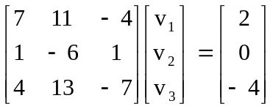

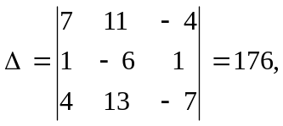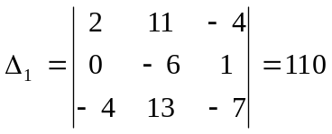

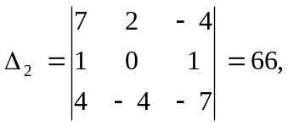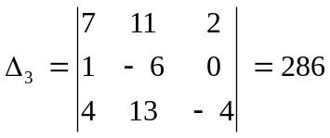

v₁ = 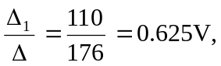 v₂ = 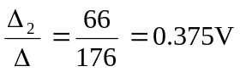

v₃ = 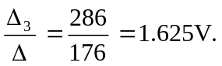

v₁ = 625 mV, v₂ = 375 mV, v₃ = 1.625 V.

